**To Create a Maven Project:**

mvn archetype:generate

-DgroupId=com.myprogram

-DartifactId=mymavenproject

-DarchetypeArtifacId=maven-archetype-quickstart

-DarchetypeVersion=1.0

-DinteractiveMode=false

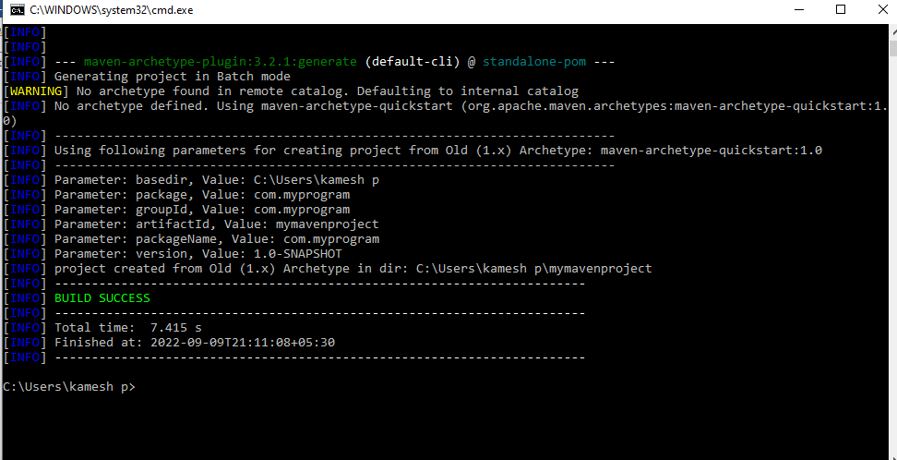

**To create a Target file: C:\Users\kamesh p\mymavenproject >mvn package**

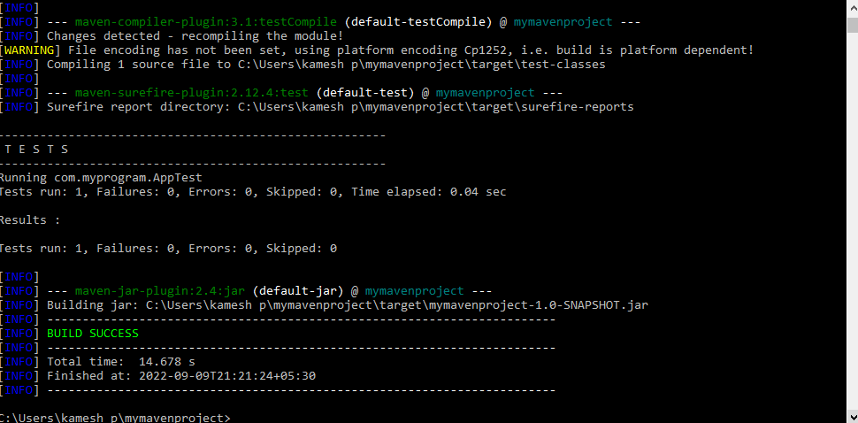

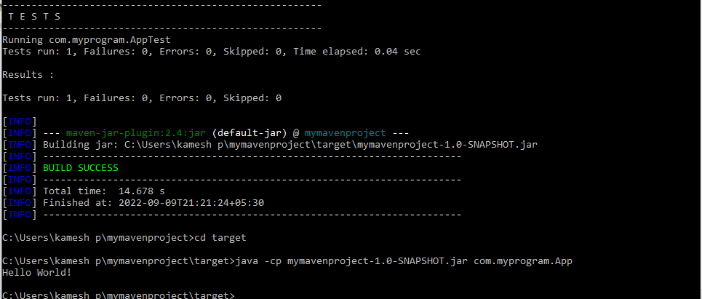**To Run the Program:**

**C:\Users\kamesh p\mymavenproject\target>java -cp mymavenproject-1.0-SNAPSHOT.jar com.myprogram.App**

